Burundi

## GNI per capita and development level

The data set shows the GNI per capita and development level of the country each year.

## # A tibble: 19 x 5  
## country iso3c date GNIperCapita devCategory  
## <chr> <chr> <dbl> <dbl> <chr>   
## 1 Burundi BDI 1996 509. Low Income   
## 2 Burundi BDI 1998 239. Low Income   
## 3 Burundi BDI 2000 233. Low Income   
## 4 Burundi BDI 2002 229. Low Income   
## 5 Burundi BDI 2003 218. Low Income   
## 6 Burundi BDI 2004 220. Low Income   
## 7 Burundi BDI 2005 218. Low Income   
## 8 Burundi BDI 2006 224. Low Income   
## 9 Burundi BDI 2007 225. Low Income   
## 10 Burundi BDI 2008 229. Low Income   
## 11 Burundi BDI 2009 228. Low Income   
## 12 Burundi BDI 2010 233. Low Income   
## 13 Burundi BDI 2011 234. Low Income   
## 14 Burundi BDI 2012 238. Low Income   
## 15 Burundi BDI 2013 243. Low Income   
## 16 Burundi BDI 2014 245. Low Income   
## 17 Burundi BDI 2015 228. Low Income   
## 18 Burundi BDI 2016 220. Low Income   
## 19 Burundi BDI 2017 214. Low Income

## GDP growth and economic growth classification

The data set shows the GDP growth and the ecomic growth classification of the country each year.

## # A tibble: 19 x 5  
## country iso3c date GDPannualGrowthRate GDPgrowthCategory4  
## <chr> <chr> <dbl> <dbl> <fct>   
## 1 Burundi BDI 1996 -8.00 negative grwoth   
## 2 Burundi BDI 1998 4.75 moderate growth   
## 3 Burundi BDI 2000 -0.857 negative grwoth   
## 4 Burundi BDI 2002 4.45 moderate growth   
## 5 Burundi BDI 2003 -1.22 negative grwoth   
## 6 Burundi BDI 2004 4.83 moderate growth   
## 7 Burundi BDI 2005 0.900 slow growth   
## 8 Burundi BDI 2006 5.41 moderate growth   
## 9 Burundi BDI 2007 3.45 moderate growth   
## 10 Burundi BDI 2008 4.86 moderate growth   
## 11 Burundi BDI 2009 3.81 moderate growth   
## 12 Burundi BDI 2010 5.12 moderate growth   
## 13 Burundi BDI 2011 4.03 moderate growth   
## 14 Burundi BDI 2012 4.45 moderate growth   
## 15 Burundi BDI 2013 4.92 moderate growth   
## 16 Burundi BDI 2014 4.24 moderate growth   
## 17 Burundi BDI 2015 -3.90 negative grwoth   
## 18 Burundi BDI 2016 -0.600 negative grwoth   
## 19 Burundi BDI 2017 0.500 slow growth

## Development trend

The plot shows the development trend of the country.

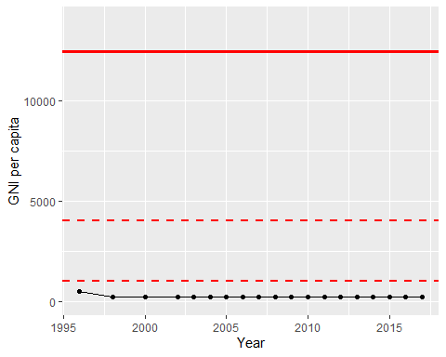

GNI Per Capita Trend